**Project Management Plan (PMP)**

Stright Entertainment’s

Group **Members** with % of contribution**:**

1. John 25%

2. Tim Valentine 25%

3. Noah Knepp 25%

4. Derrick Swint 25%

Client: Gamerz

Proposed System Background

1. **Introduction**
   * Introduction

We are making an FPS game, the main focus of this is to bring a new concept to the world of PC FPSs.

* + Purpose of the system

This new game will bring concepts from physics-based puzzles to FPS games. This will encourage the use critical thinking to progress through a series of levels. The players will have unconventional means of movement available to them to help them traverse these levels.

* + Scope of the system (boundary of the system)

The game will be built upon a level system, with the first levels acting as a tutorial for players to get used to different systems in the game. From there the levels will start easy and progress in difficulty. Along with earning points for level completion, players can also earn extra points and rewards based on their speed through the level, as well as components such as stealth.

* + Objectives and success criteria of the project

We hope to create a new genre of FPS, where the focus would be on how you can manipulate the environment to your advantage to win the game, rather than just shooting enemies. Success can be determined by the player base (large player base = successful, small player base = unsuccessful) and if similar games start appearing/getting more popular.

* + Definitions, acronyms, and abbreviations

FPS – First Person Shooter

1. **Overview**
   * Current system

This will be a brand-new system offering a new FPS experience to PC players.

* + Proposed system

This will allow for a new genre of FPSs to emerge, ideally being the standard of its type.

1. **Functional requirements**

*The third section documents the requirements elicitation and the analysis model of the new system.* *Functional requirements describe the high-level functionality of the system.* *Example modules are but not limited to*

* + Admin User Module
    - Permissions to edit everything (functionality, design, virtual environments, etc.)
  + Users’ Module
    - Registration for users
    - Login/logout for users
  + Game Module
    - Player Statistic viewer
    - Leaderboard system
  + Email Module
    - Popular emails (gmail, yahoo, etc.) for account registration
  + Reporting Module
    - Bugs

1. **Nonfunctional requirements**

*Nonfunctional requirements describe user-level requirements that are not directly related* *to functionality. This includes*

* + Usability / user friendly / easy to learn for a new user (Friendly to new users wanting to explore a new genre of FPS)
  + Reliability (Will be backed up to GitHub)
  + Performance (Consistently above 30 Frames per second)
  + Supportability (Windows)
  + Legal Requirements

1. **Hardware requirements**

*At minimum, Intel i5/Ryzen 5 x*

*At minimum, Nvidia 960/Radeon RX 460*

*Recommended 16 GB of DDR4 RAM*

*30GB of storage*

*SteamCMD*

1. **System models**
   * Context diagram

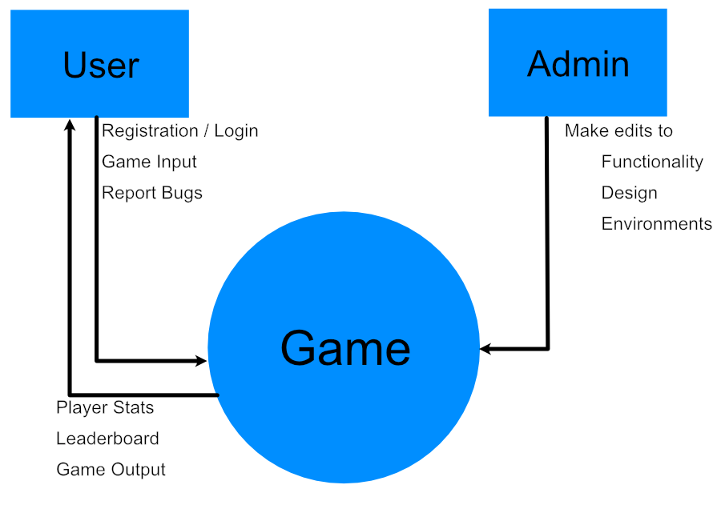

* + Use case model and use case descriptions
  + Class diagram if applicable
  + ERD if available
  + User interface if available,

🡺if not available due time limitations, start thinking about the above artifacts

**Team members skills assessment:**

*Estimate each team member’s skill level on a scale of 1-10 for all technologies to be used in the project. Sample technologies are shown below; your list may vary.*

|  |  |  |  |  |
| --- | --- | --- | --- | --- |
| ***Skill*** | ***John*** | ***Tim*** | ***Derrick*** | ***Noah*** |
| Python | 8 | 6 | 7 | 6 |
| Java | 9 | 9 | 8 | 9 |
| Java / Python / JavaScript using Node.js | 2 | 2 | 2 | 3 |
| User Interface / GUI / CSS | 5 | 5 | 5 | 5 |
| PHP | 4 | 3 | 2 | 4 |
| PHP/JSP/C# / ASP.Net | 3 | 3 | 2 | 3 |
| MySQL | 5 | 4 | 4 | 5 |
| SQL/MySQL/mongoDB | 5 | 4 | 4 | 5 |
| MVC | 6 | 6 | 6 | 7 |

**Glossary**

FPS – First person shooter

PC – Personal computer

Stealth Points – Additional points gained for meeting established stealth goals.

Speed Points – Additional points gained for completing a level quickly.

Destruction Points – Additional points gained when killing an enemy and/or destroying the environment.

Local leaderboard – Leaderboard that tracks players previous attempts and ranks them based on total points accumulated.

**Submission Details (*not part of PMP*)**

Due Dates:

* Presentation of PMP will be during class on Wednesday, Sept. 1 (5 points)
* PMP is due on Wednesday, Sept. 1 at 11:59 pm (10 points)

Extra Credit Opportunities:

Extra credit may be earned by implementing either or both of the following. The points apply to the entire project, not each task.

* Model-View-Controller (MVC) architecture (10 points)

Use the MVC design pattern in your system architecture. This should begin early on in the coding in Sprint 1.

* Test Automation (10 points)

Automated testing of your product using the free software called Selenium (<https://www.selenium.dev/>). You may earn 2 points for each sprint in which you perform automated testing.